|  |  |  |  |  |
| --- | --- | --- | --- | --- |
| **SR.**  **NO** | **ASSIGN.**  **DATE** | **SUBM.**  **DATE** | **TITLE** | **TEACHER’S**  **REMARK** |
| **1.** |  |  | **PRACTICAL.I** |  |
| **2.** |  |  | **PRACTICAL.II** |  |
| **3.** |  |  | **PRACTICAL.III** |  |
| **4.** |  |  | **PRACTICAL.1V** |  |
| **5.** |  |  | **PRACTICAL.V** |  |
| **6.** |  |  | **PRACTICAL.VI** |  |
| **7.** |  |  | **PRACTICAL.VII** |  |



**NAME=BABITA KARMIYAL**

**DEPARTMENT=BCA(HLD)**

**UNIVERSITY.ROLL.NO=2092011**

**STUDENT ID=20042268**

**PYTHON PRACTICAL PROGRAMMING**

**INDEX**

**PYTHON PRACTICAL QUESTION:I**

**#WAP TO PRINT YOUR NAME,AGE,ADDRESS,COURSE,SEMESTER**

**,ADDRESS,UNIVERSITY ROLL NO.**

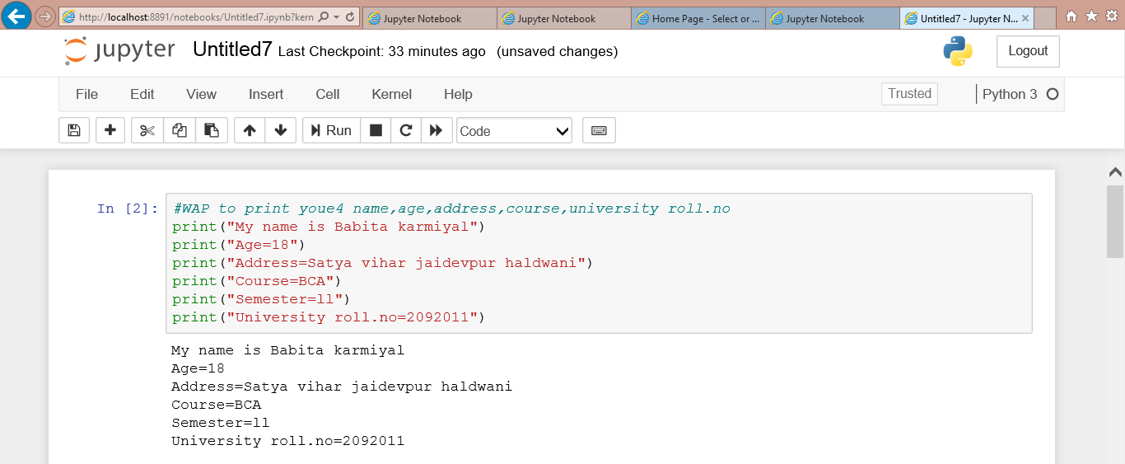

**2.WRITE A PYTHONE PROGRAM TO SWAP TWO NUMBERS**

**WITHOUT USING ANY VARIABLES.**

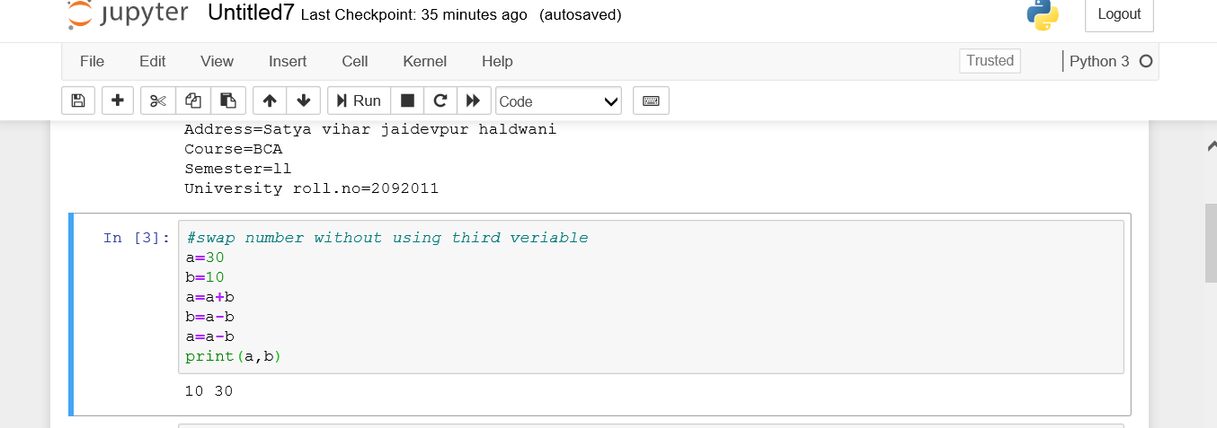

**.WRITE A PYTHON PROGRAM TO PRINT THE TABLES OF 5 AND 10**

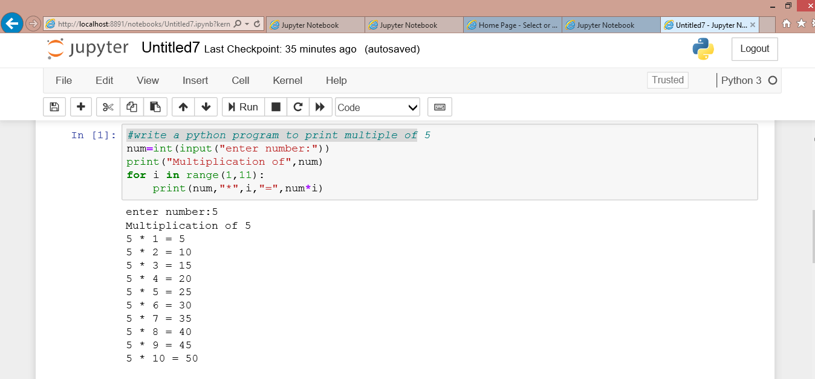

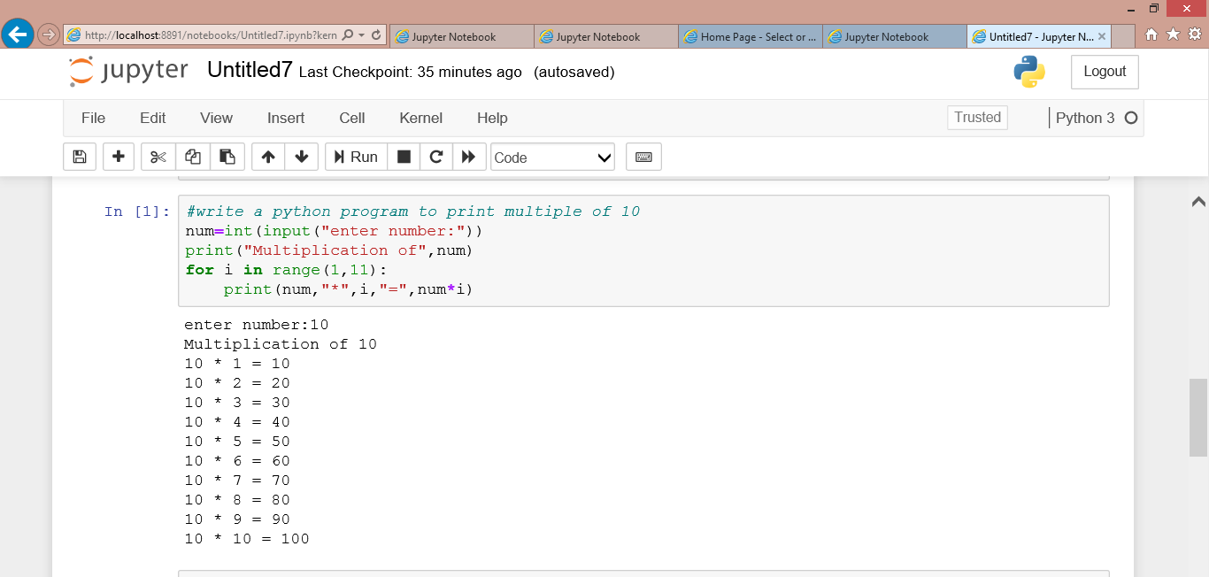**PYTHON PRACTICAL PROGRAMMING 2:**

**1.WRITE A PYTHON PROGRAMM TO PRINT “HELLO STUDENT HOW ARE YOU”AS”HOW ARE YOU HLLO STUDENTDS” FIVE TIME WITHOUT USING PRINT STATEMENT 5 TIMES**

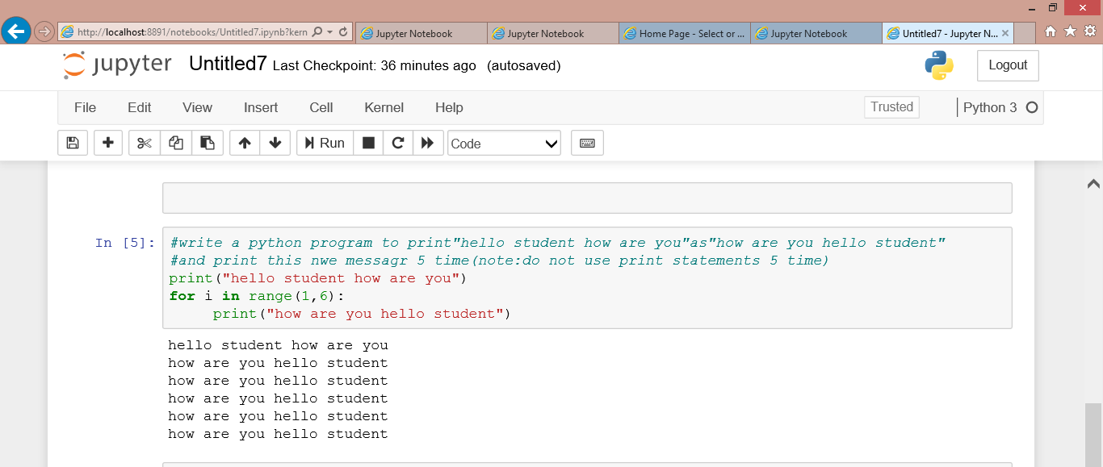

**2.ASSUME ANY STRING WHICH CONTAINS”SECOND SEMESTER”,REPLACE IT WITH “THIRD SEMESTER”.ALSOCPRINT THE POSITION OF THIRS SEMESTER**

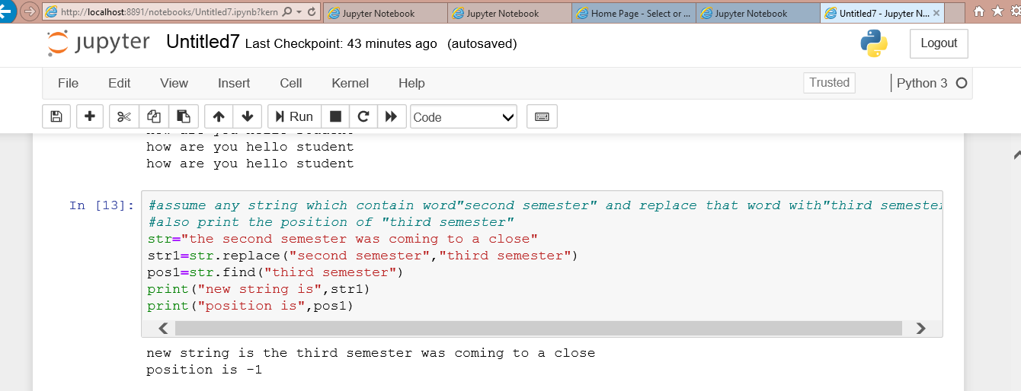

**3.TAKE ANY STRING WHICH CONTAINS MORE THAN TWO LINS ABOUT YOU.NOW COUNT NUMBER OF TIMES”I” OCCURS IN THE STRING**

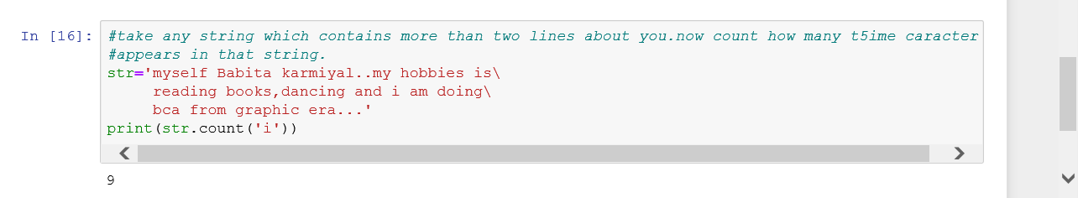

**4.consider any long string .now replace the space between two words with the tab.**

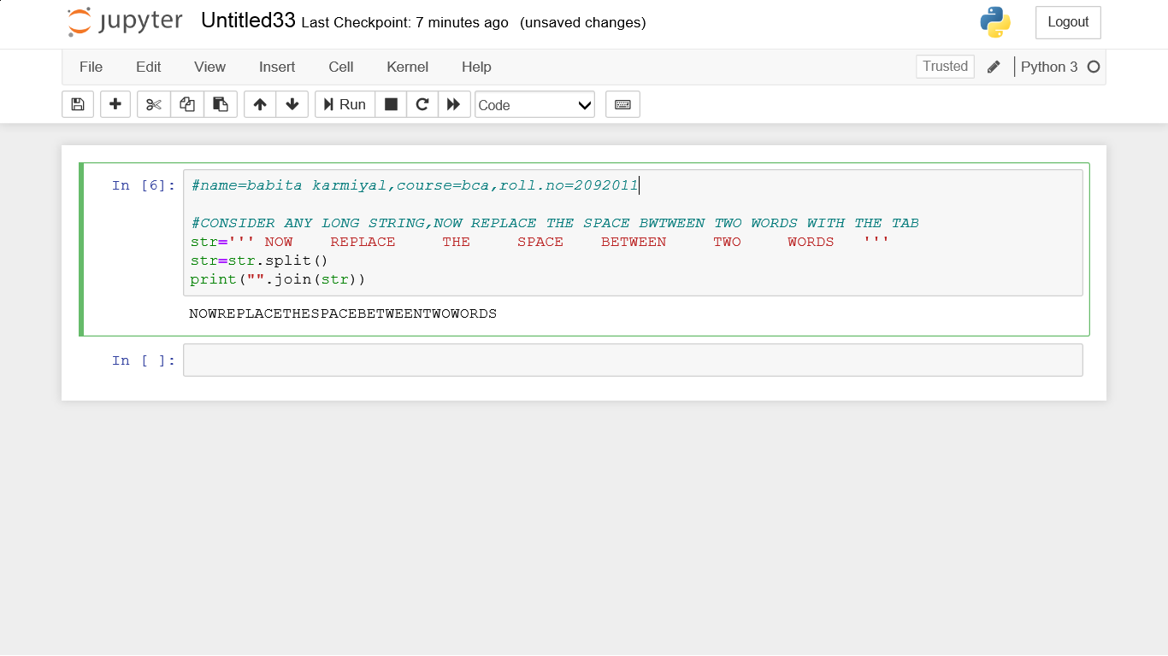

**5.write a pyton program which can identify and print output whether a given string is a website name or not**

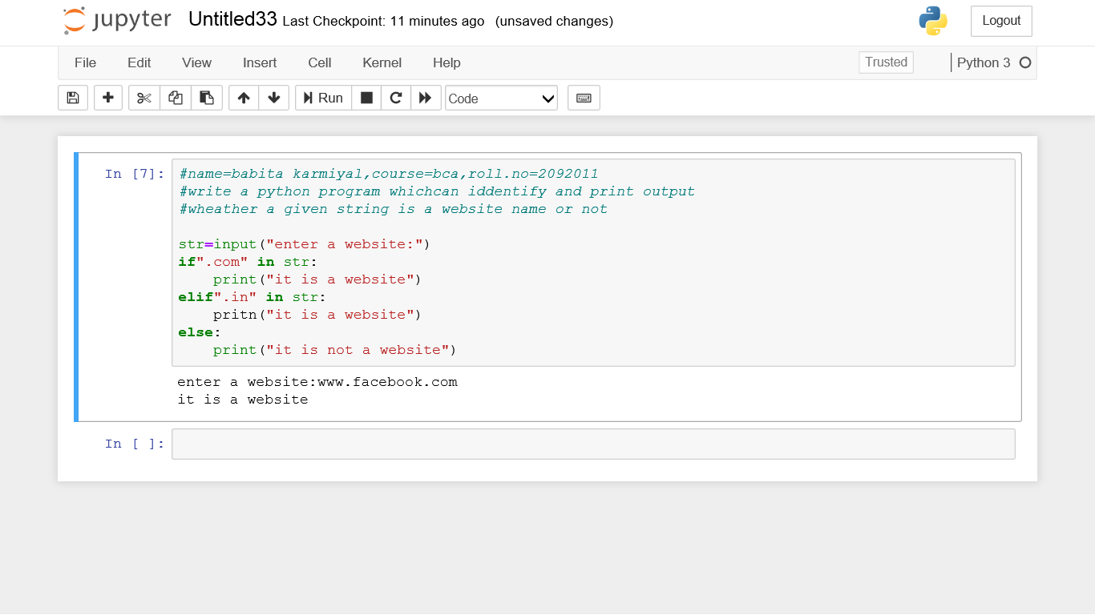

**Python practical question;3**

**1.take any list and print it in following manner,**

**a)print onl;y last three element**

**b)print all valus except the first and last value**

**c)print only three element**

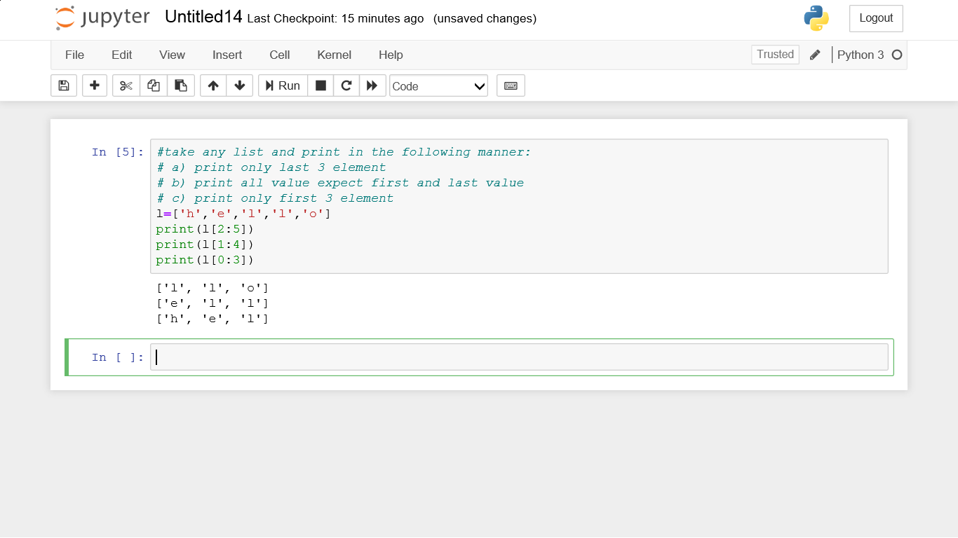

**3.consider any tuple containing integer,decimal and string values.now delete all decimal values and then add three character values in it**

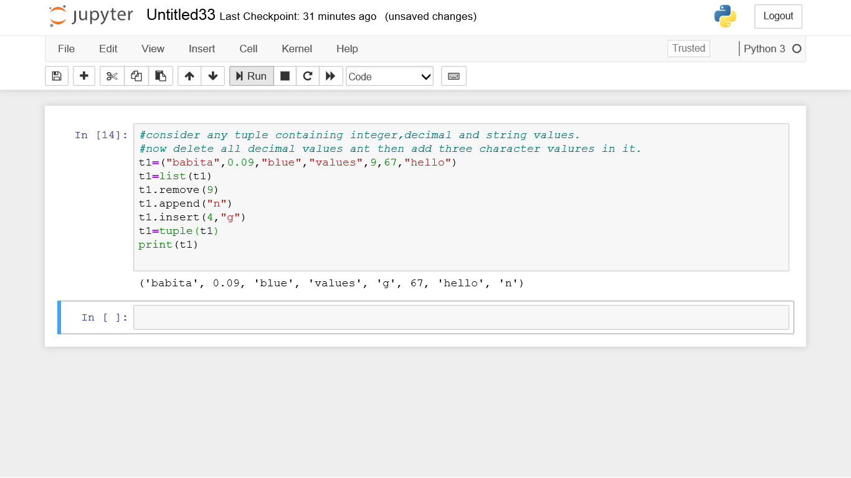

**2.in a python consider any list containing integer,decimal and string values,now delete all decimal values using any list delete functions and then add three character in it.**

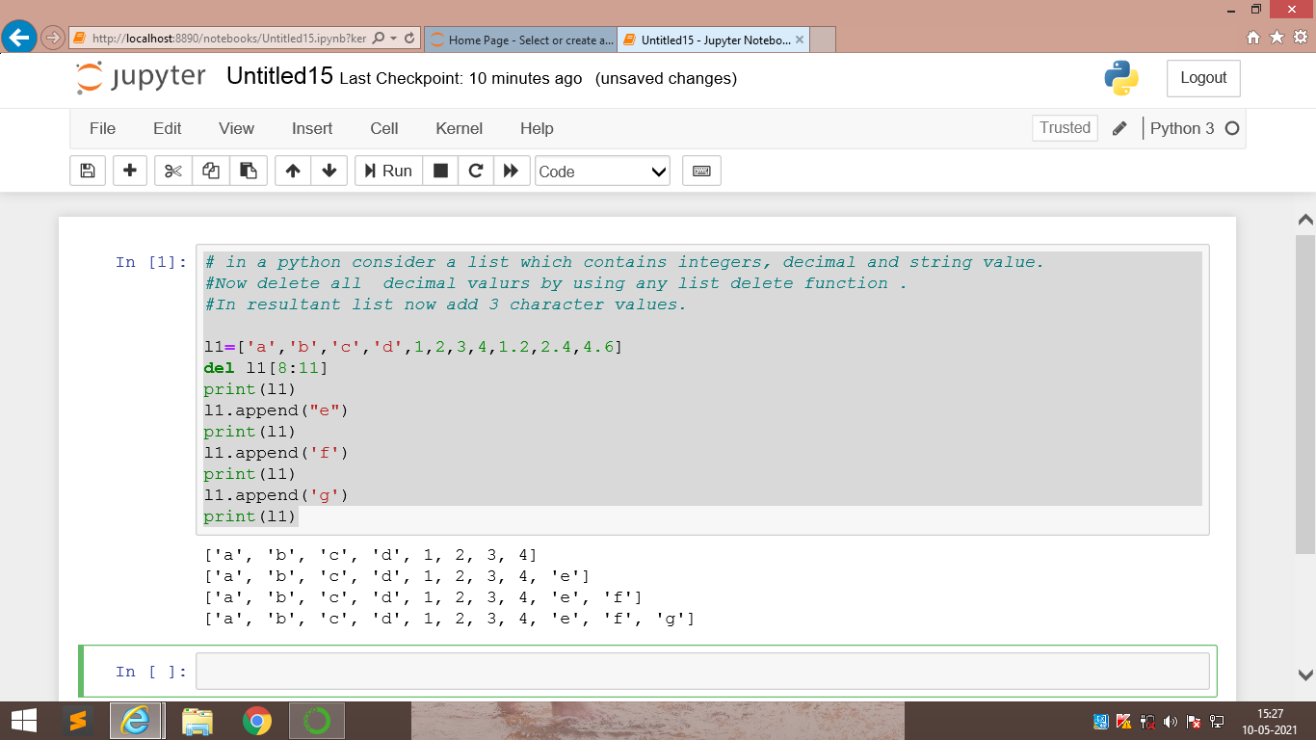

**Python practical question:4**

**Make a dictionary in which the keys are the numbers and the values are their cubes. now first print the dictionary and then print th values of the dictionary**

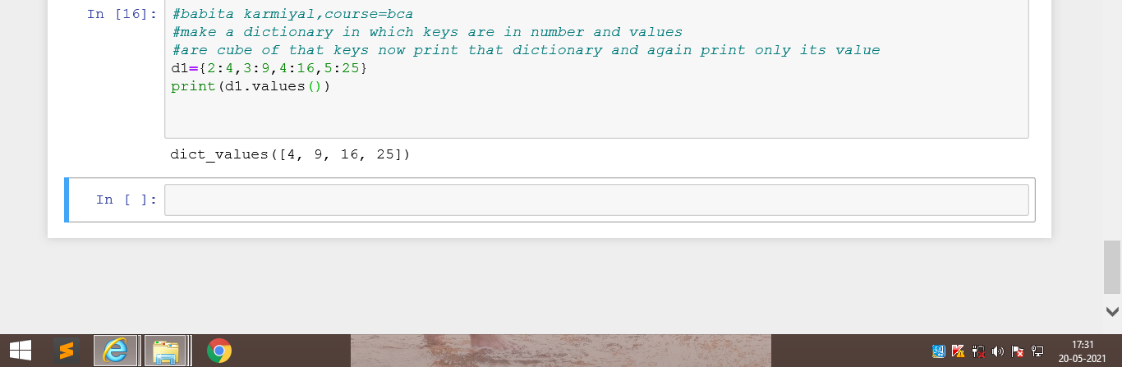

**2.consider an existing dictionary with some existing values.first empty the dictionary and tn add some new key-value pairs to it.**

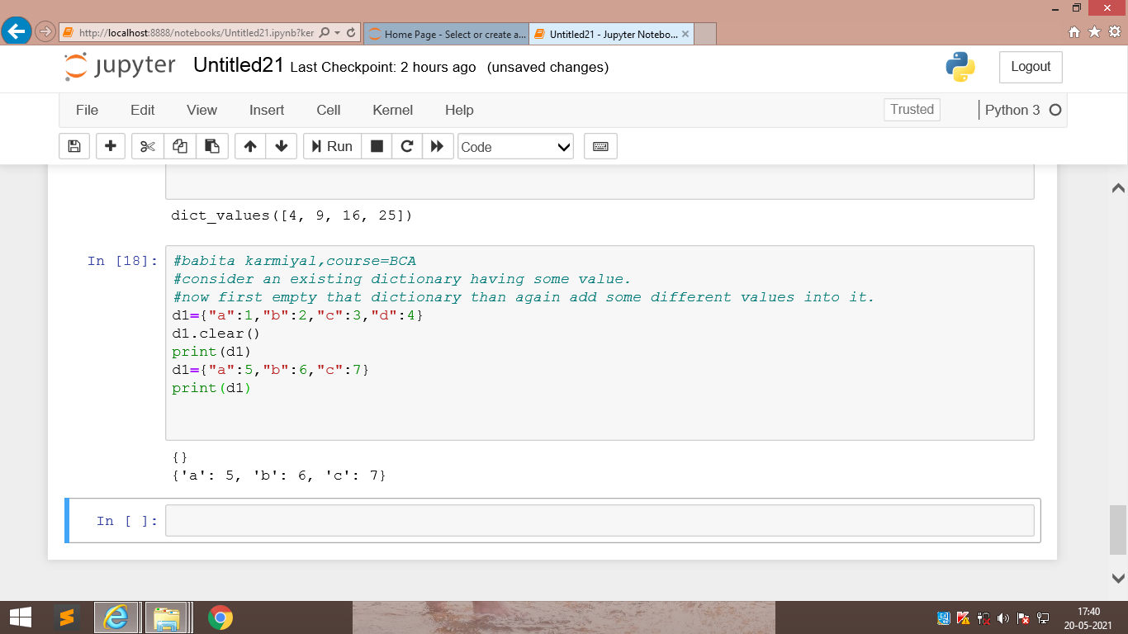

**3.write a python program to check any 5 values that is present in an existing dictionary or not**

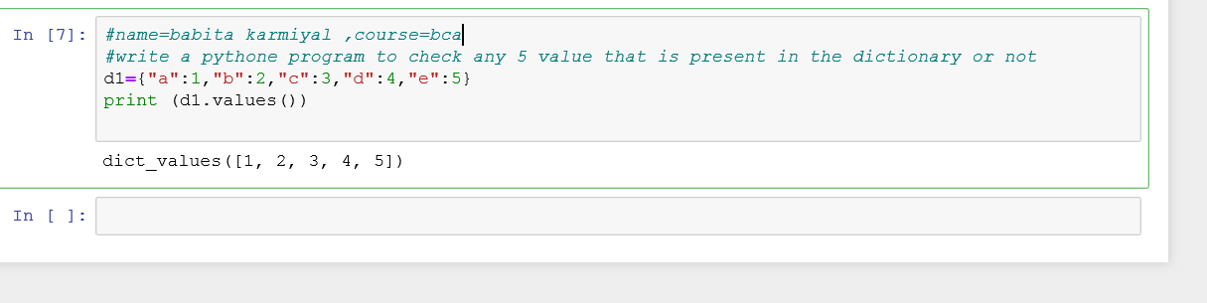

**Python Practical question.5**

**1.write a python program to check if the value entered by the user is a palindrome or not**

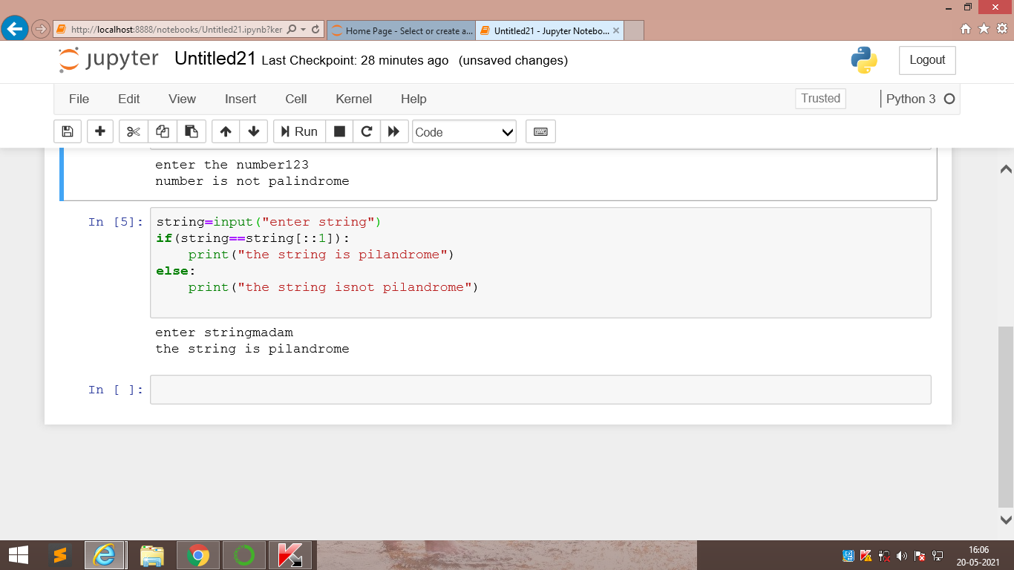

**2.write a python program to check if the value entered by uses is a Armstrong number or not**

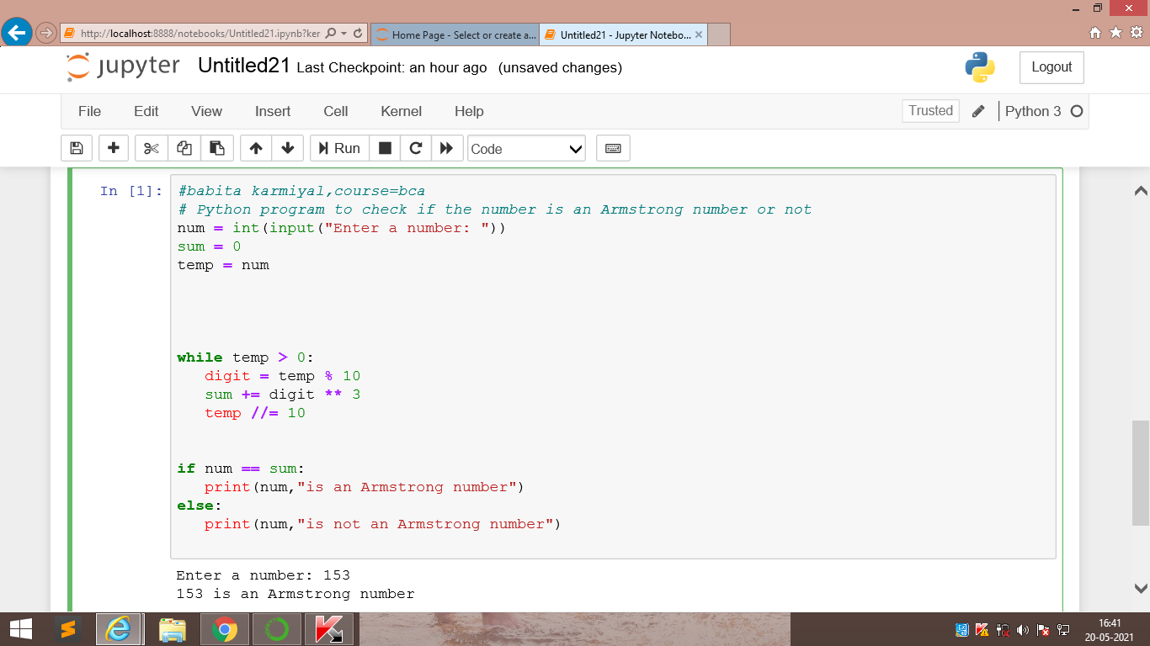

**3.consider a numbr given input by the user .now find the factorial of the number**

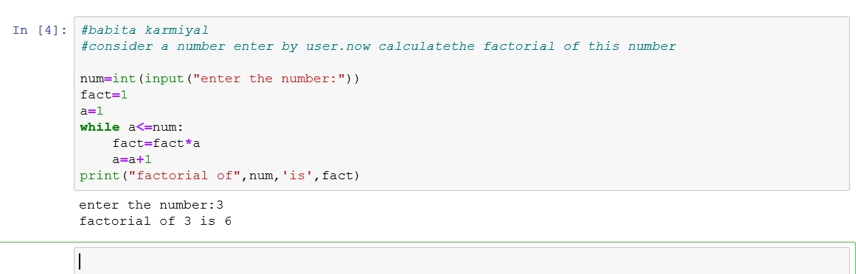

**4.Write a python program to print the Fibonacci sequence upto the range given by the user.**

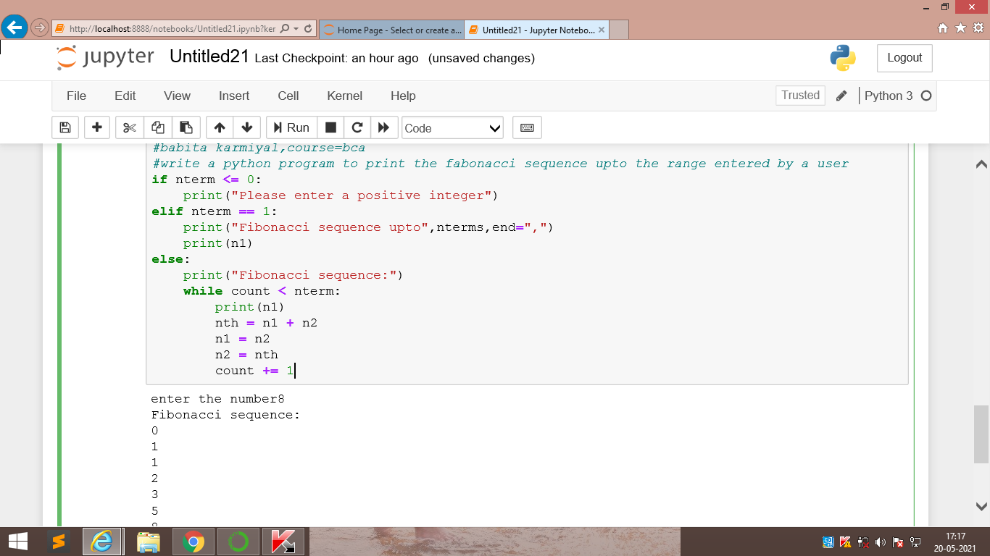

**5.write a python program to chck whether th number entered by the user is a perfect number or not**

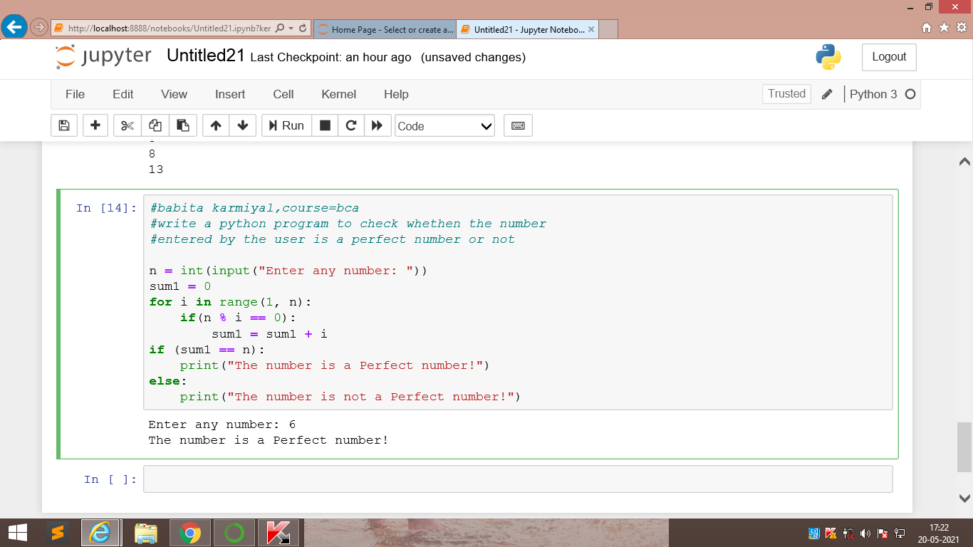

**Python practical question.6**

**Write a python program to remove duplicate values from a list**

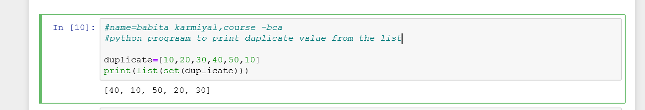

**2.write a python program to get a string from the user and check if it start with “is”or not.if not then add is with it**

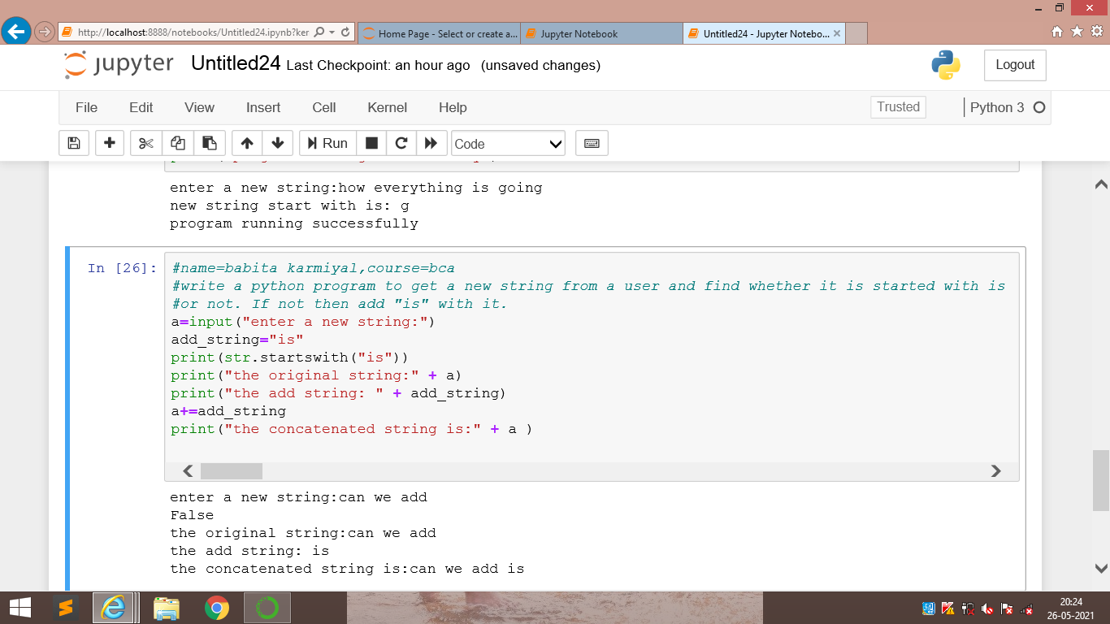

**3.write a python program to count the number of alphabets ,digits and symbol in the string given by the user**

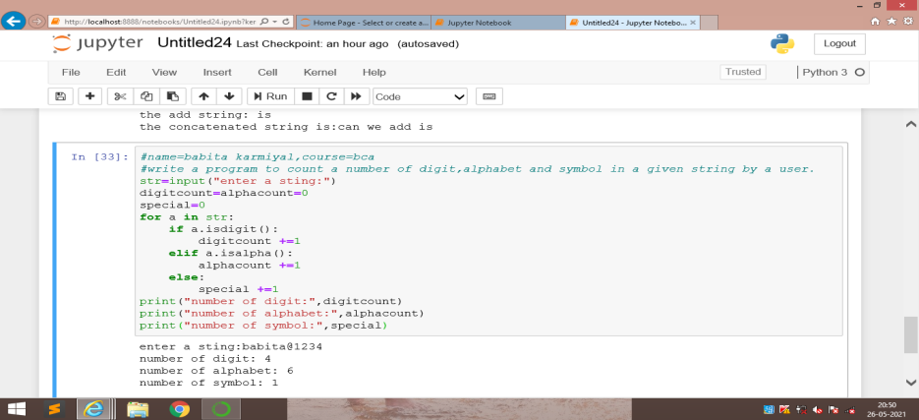

**4.take two dates of same months and same year from the user in the format dd/mm/yy.now compare only the dates and calculate the number of days between the two dates and also print which date comes first**

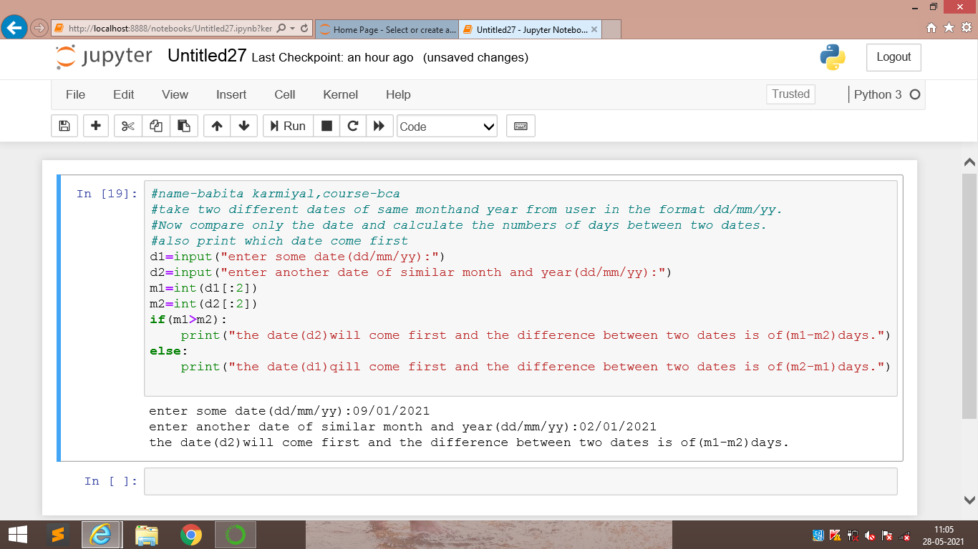

**5.a student is not allowed to sit in exam ,if his/her attendance is less than75%.take following inputs from the user:**

**a)number of classes held**

**b)number of classes attended**

**print the percentage of class attended and also tell if h/she will sit in the exams.**

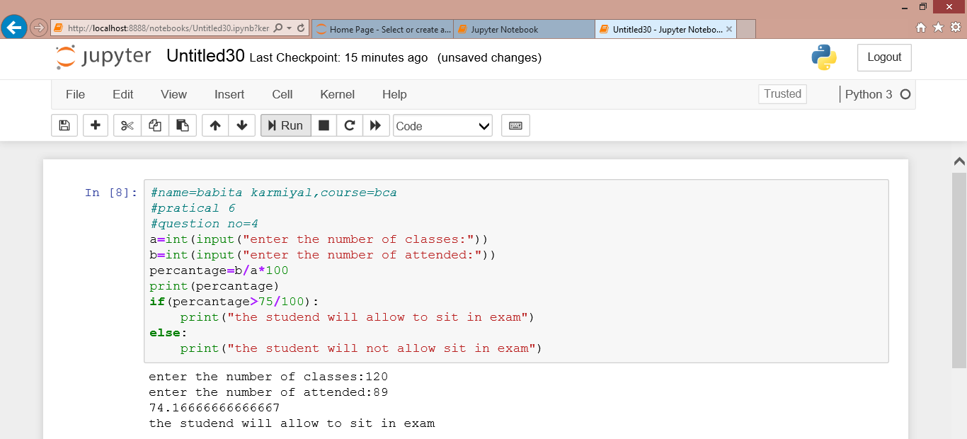

**python practical question:7**

**1.write a python program having a user defined function which will calculate the total number of vowels in a string given by the user.**

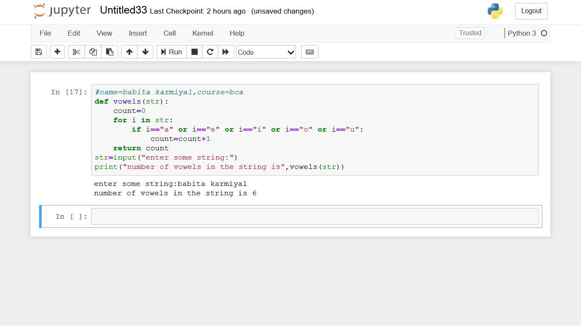

**2.a shop will give discount of 10% if the cost of the purchased quantity is more then 1000 rupees.now write a python on program having a user defined function which will first calculate whether the purchased quantity is more then 1000 rupees or not and then accordingly it will print the total cost for the user.**

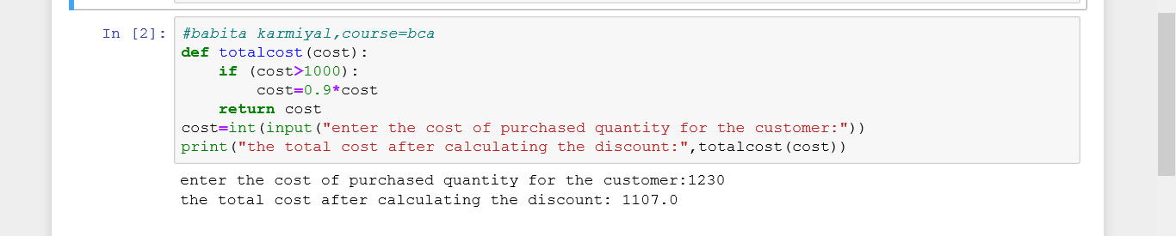

**3.suppose a company dcided to give a bonus of 5% to their employee if his /her year of service in the company is more than 5 year.now rite a python program having a usr define function which will print the net bonus amount .ask user to input the salary and the year of service**

